**ABendaid tips**

* To
* 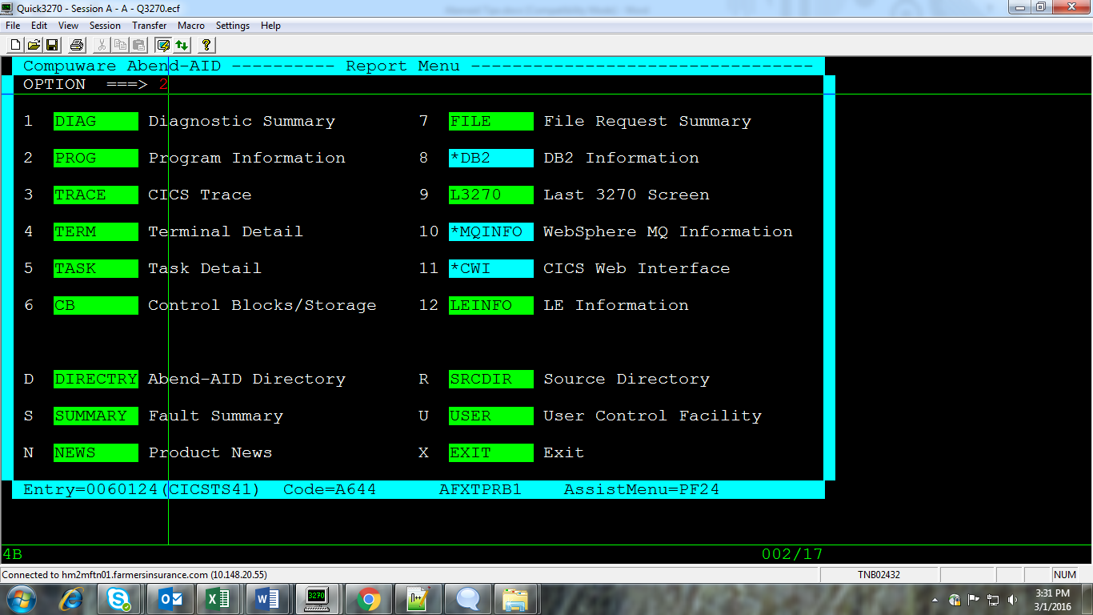

**Debugging error with Abendaid in Cics**

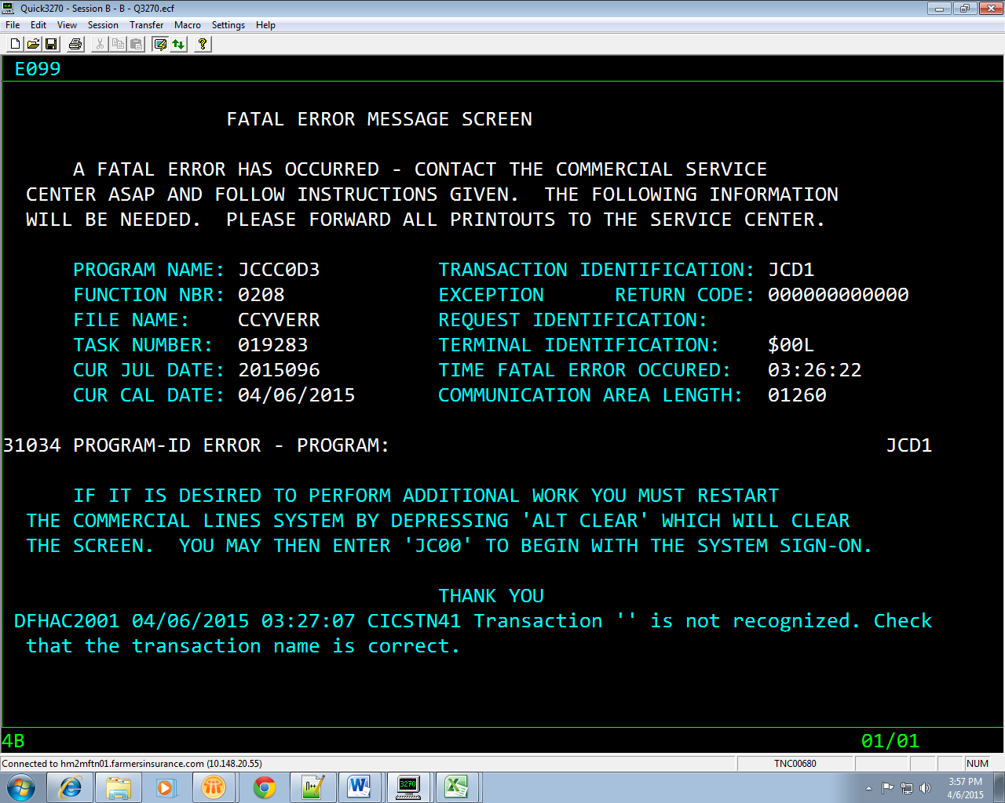

Search for the abend code by entering the transaction **AADF** in CICS. Press PAUSEBREAK

For getting blank screen to enter the transaction. We can get the program name and offset of error here in the table. Then go to Endevour listing to find the source of error

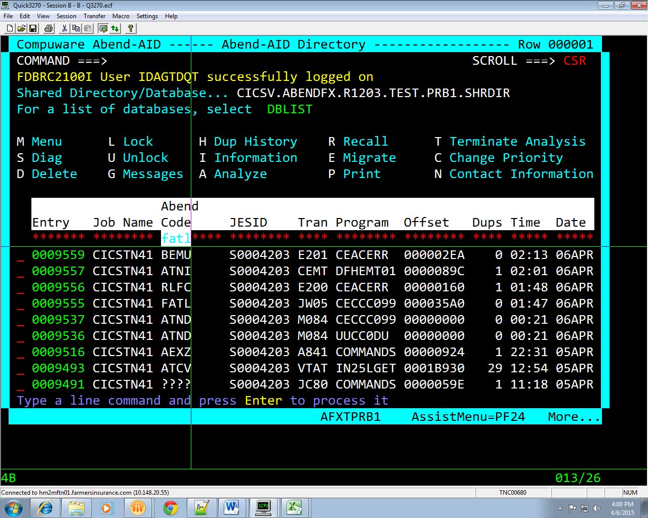

Press enter before the error and then select L3270 to view the CICS screen

